ASSIGNMENT 4: LOGISIM

U19CS012 [D-12]

Use Logisim software to create and store the followings circuits for further usage: (For Practice)

1. 4-bit half adder

Circuit Image:

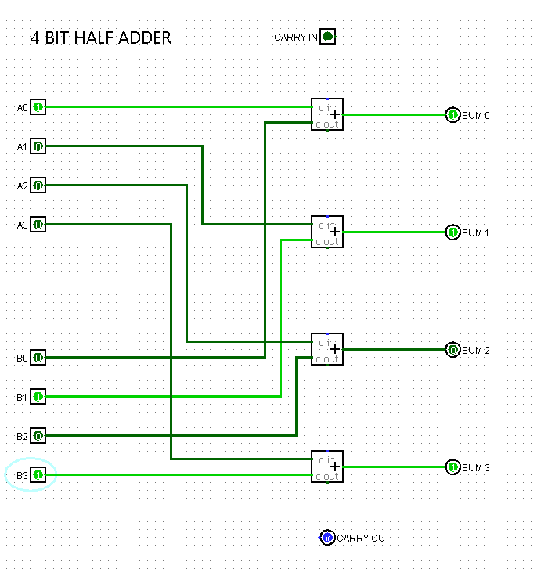

Truth Table:

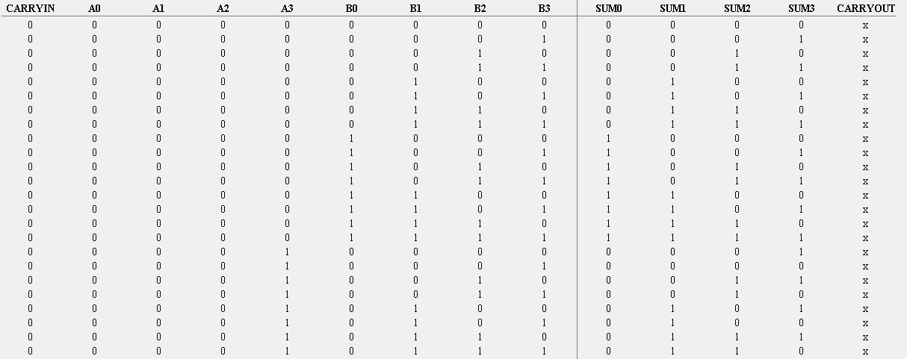

2. 4-bit full adder

Circuit Image:

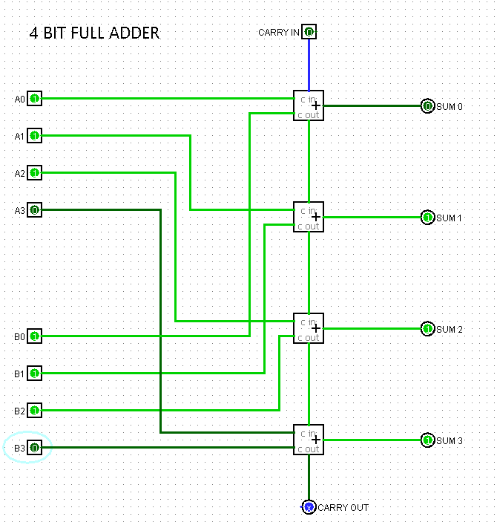

Truth Table:

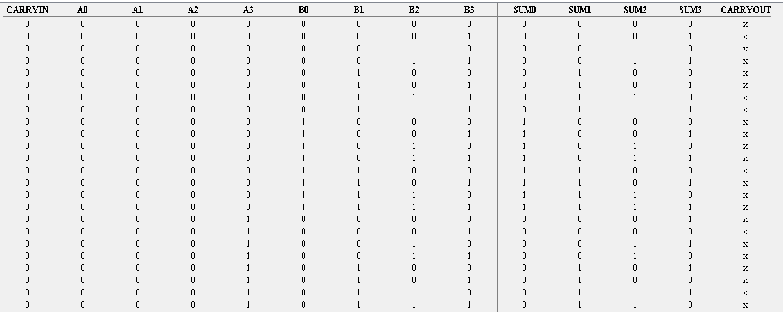

3. 4-bit half subtractor

Circuit Image:

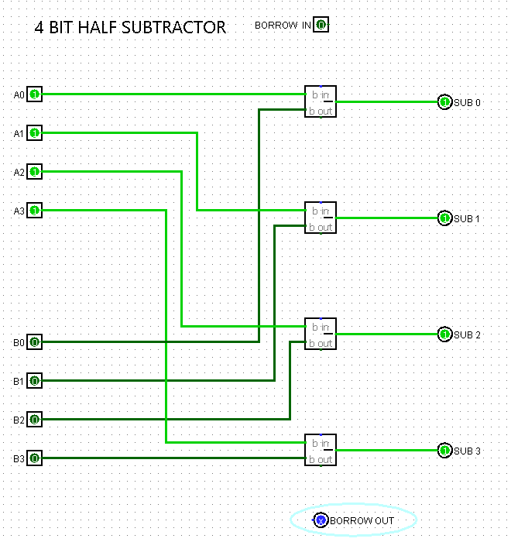

Truth Table:

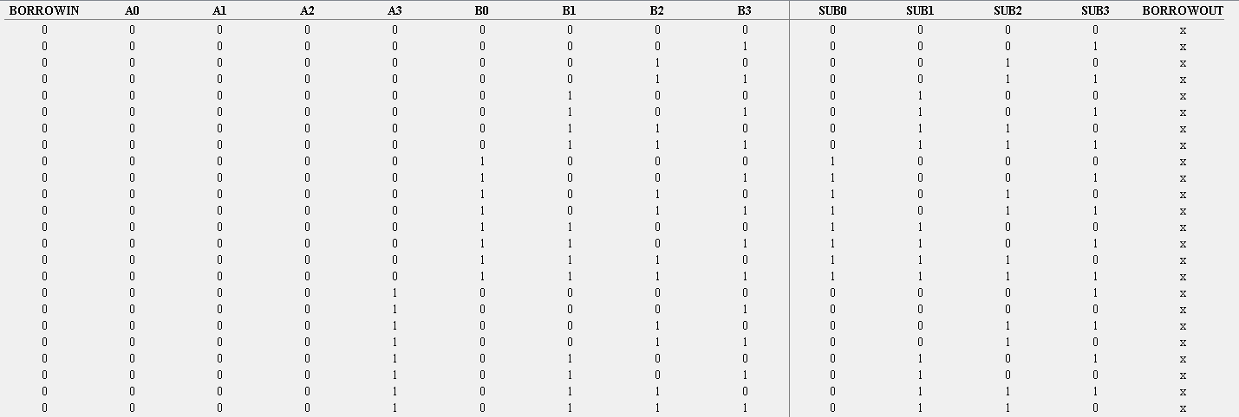

4. 4-bit full subtractor

Circuit Image:

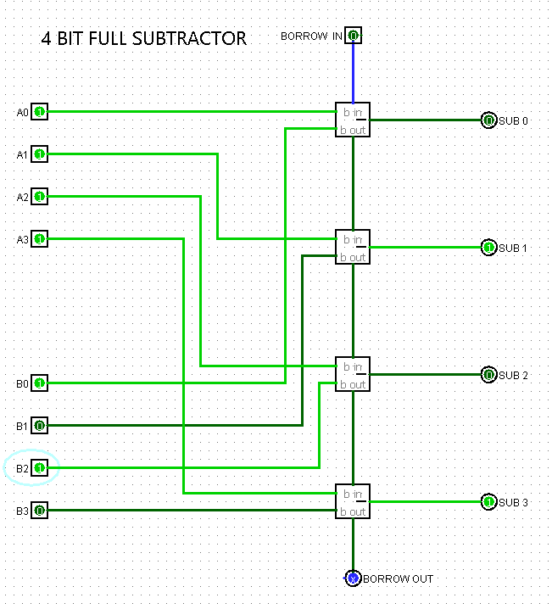

Truth Table:

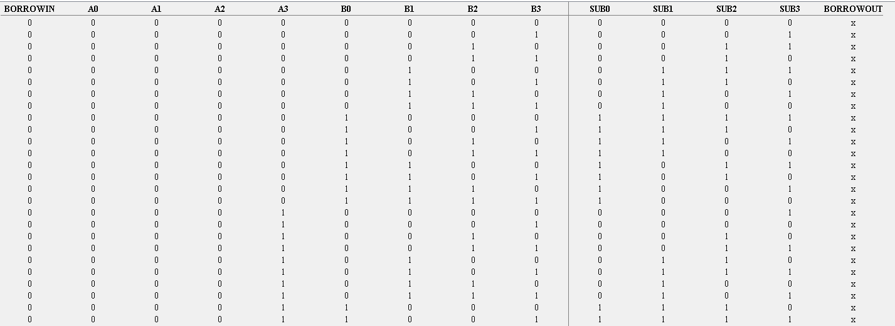

5. Using the previously built 4-bit half adder, build 8-bit half adder

Circuit Image:

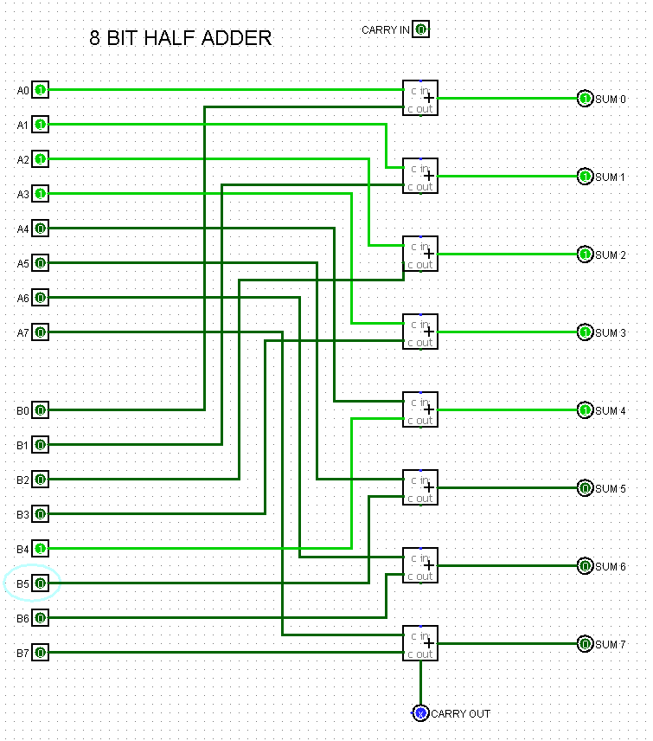

Truth Table: [Not Possible for More Than 12 Inputs: Logisim Limitation]

00001111 + 00010000 = 00011111 [Bit By Bit Adder]

6. Using the previously built 4-bit half subtractor, build 8-bit half subtractor

Circuit Image:

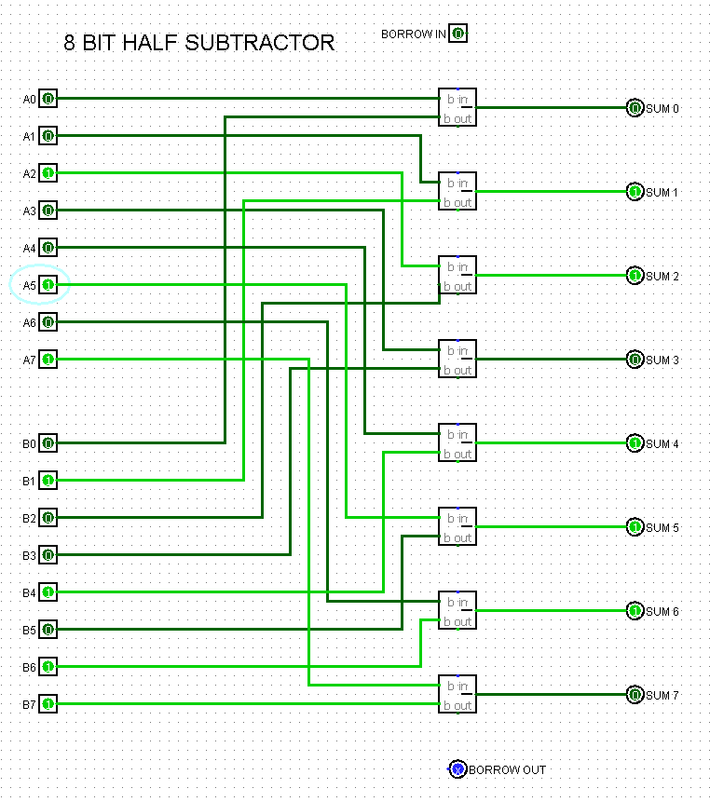

Truth Table: [Not Possible for More Than 12 Inputs: Logisim Limitation]

10100100 – 11010010 = 01110110 [Bit By Bit Subtractor]

7. Using the previously built 4-bit full adder, build 8-bit full adder

Circuit Image:

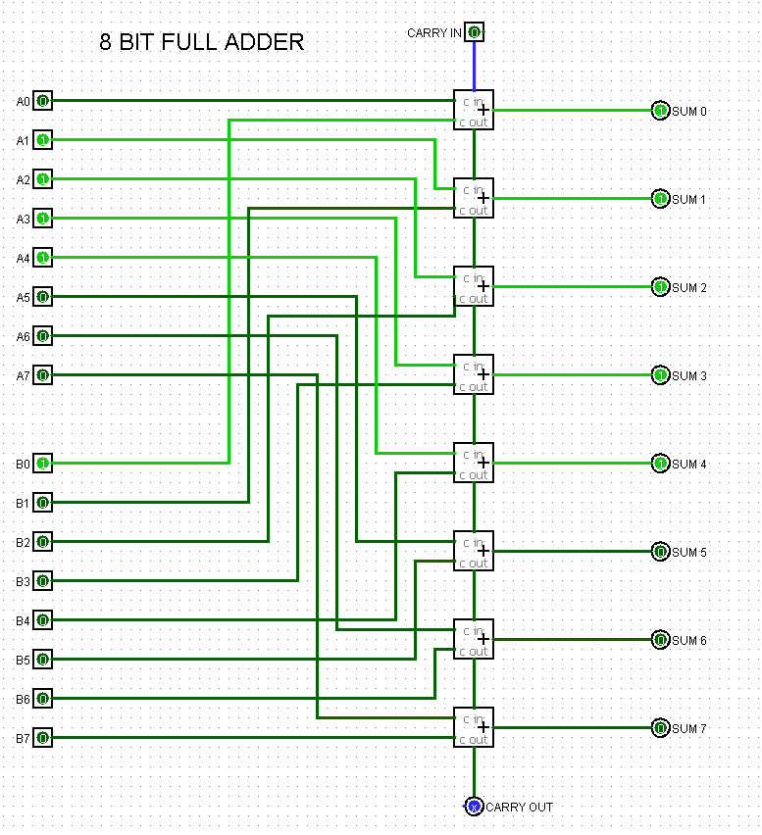

Truth Table: [Not Possible for More Than 12 Inputs: Logisim Limitation]

00011110[30] + 00000001[1] = 00011111[31] (Shown Above)

8. Using the previously built 4-bit full subtractor, build 8-bit full subtractor

Circuit Image:

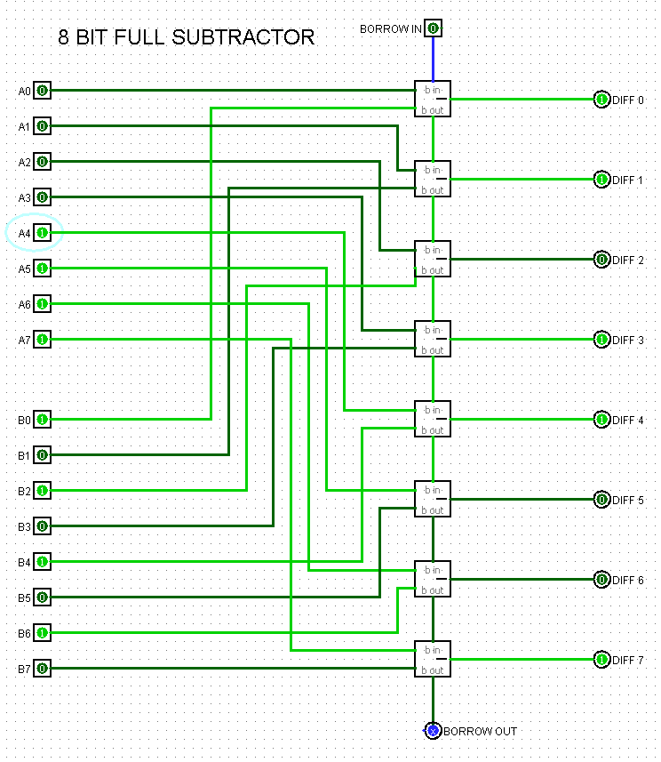

Truth Table: [Not Possible for More Than 12 Inputs: Logisim Limitation]

11110000[240] – 01010101[85] = 10011011[155] (Shown Above)